**GitHub repository where all documentation & code can be found.** [**billbill100 (github.com)**](https://github.com/billbill100)

**ESP32 generic firmware load. V1.0 23/07/2024**

**Download the code from the github page.**   
Go to the github page following the link above and then select the required project.   
Click on the green <>Code button, which will allow you to download all of the files as a zip file.  
Unzip (extract) the downloaded files.

**Download the Flashing software.**

A program called Flash Download Tool is required. It is included on the Github page, or can be downloaded from  
[Tools | Espressif Systems](https://www.espressif.com/en/support/download/other-tools)

Unzip (extract) the folder and put the files somewhere suitable on the computer. The software is stand-alone and does not need to be installed.

**Checking the ESP32 USB driver.**

The USB driver should have been installed, following the driver installation guide. To confirm, after connecting the ESP32 board, press Windows key + x and select Device Manager. Look for the COM ports and expand. The ESP module should be seen, as in this example on COM port 6, showing the CP2102 driver.

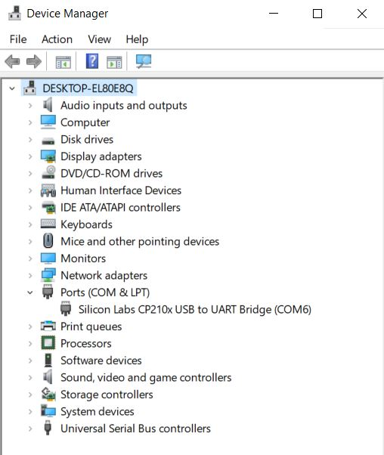

If the driver is missing, as shown on the screen below (Yellow Triangle) refer to the document Installing CP2102 Driver. Found in the github repository.

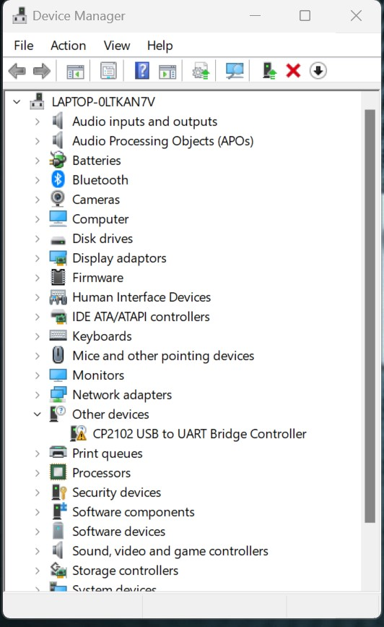

**Flash the firmware to ESP32**

Find the folder where the Flash Download Tool files were extracted to.

Launch the Flash Download Tool by double clicking on ‘flash_download_tool_3.9.5.exe’

Select ‘ESP32 from the drop-down box, as shown in the screenshot below and click ok.

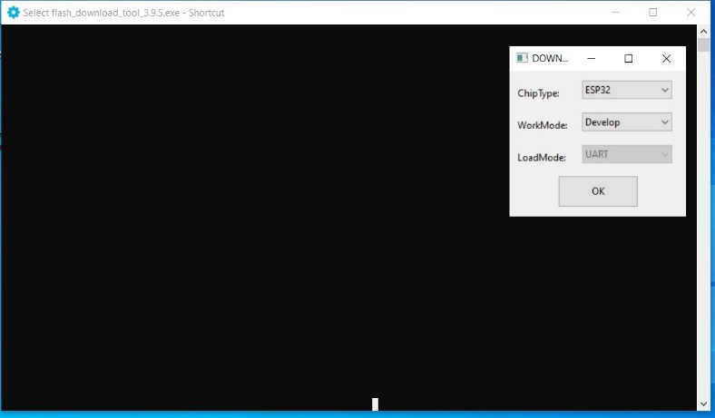

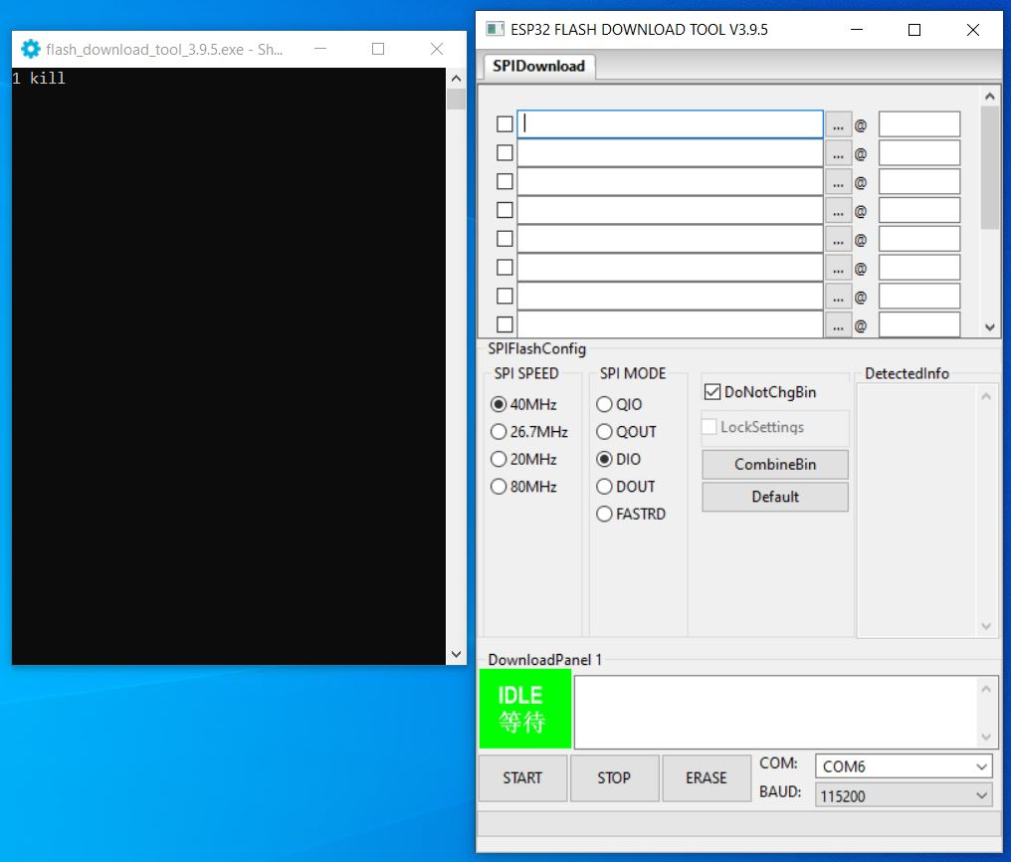A screen like the below will appear and must now be populated. (The two windows can be moved as required)

Populate the values as follows

1. Click the three dots next to the top box, navigate to, and select the downloaded *filename_x_x_x_x.ino.bootloader.bin.* file.  
   Do the same on the second line, selecting   
   *filename_x_x_x_.ino.partitions.bin*  
   and again for the third line   
   *filename_x_x_x_x.ino.bin  
   If the files are selected correctly, the black window (5) will show each file name*

(ensure the files are in the correct order)

1. Type 0x1000 into the top box, 0x8000 into the second and 0x10000 into the third.
2. Tick the three boxes next to the file names
3. Select the correct COM port from the drop-down box

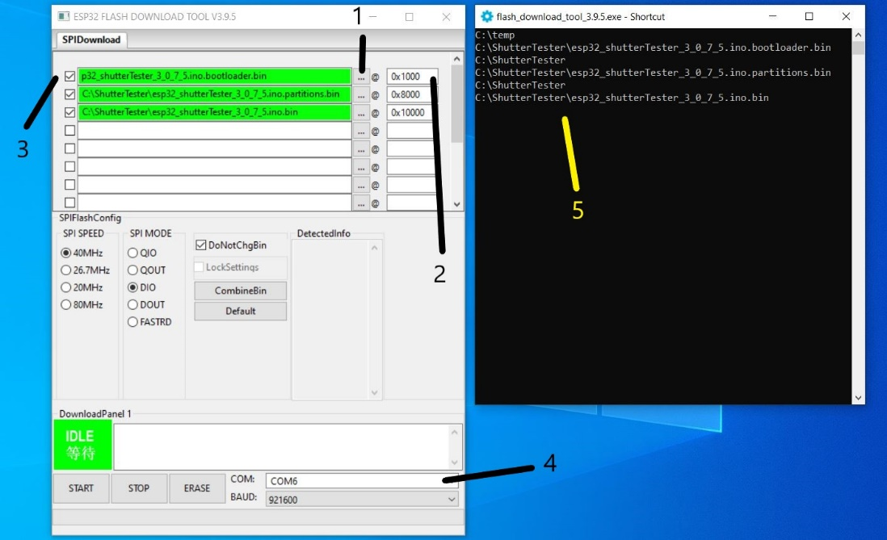

The file names and number boxes will be green, if the Flash Download Tool as found the files & is happy with the values.

Now press ‘Start’ at the bottom left of the box. The green ‘IDLE’ box will change to ‘SYNC’

A line of dots will appear on the black screen, Only if using the nodeMcu-32 board, press the Boot button on the ESP32 board for 3 seconds and then release. (The Lolinn board, as used in Lightning_Detector & Developing_Timer does not have the boot button)

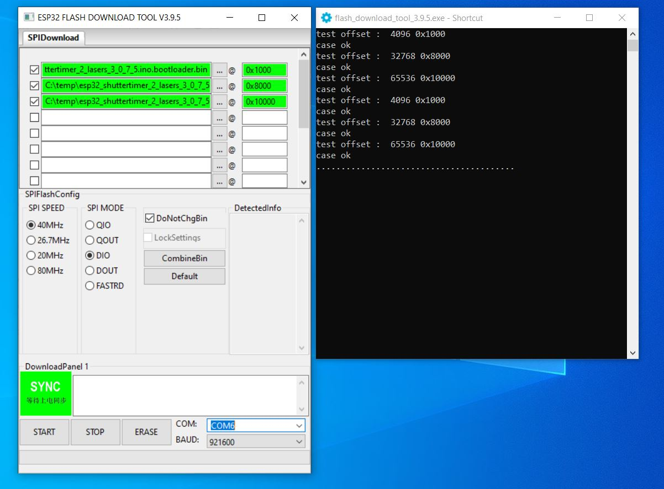

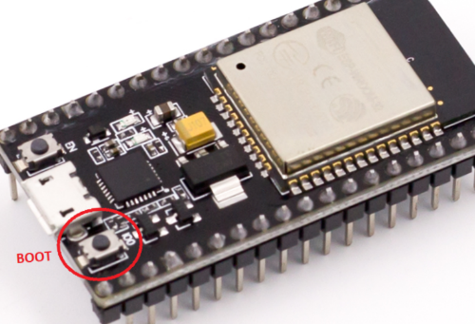

If successful, a screen, as below, will be seen. The Black screen will show the flashing to the device. A green progress bar blue box will appear in the other screen, then the green start button will change to a blue ‘FINISH’

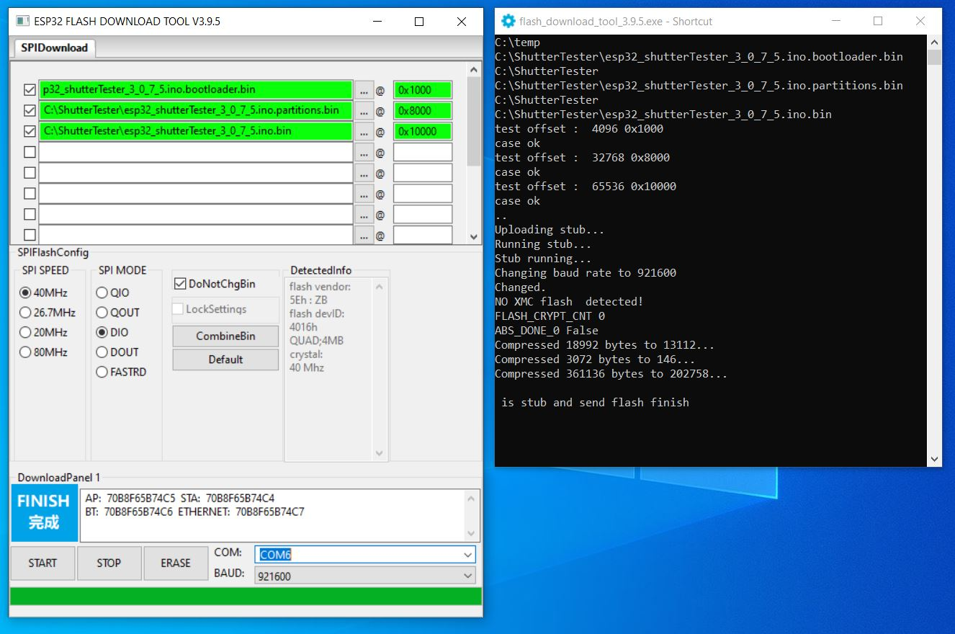

**Note:-** the flashed code will not start running until the Reset button has been pushed on the ESP32 board.

If problems occur, check the following:-

Remove & insert the USB cable into the computer. Windows, by default will make a sound indicating a USB device has been connected.  
  
Open Device Manager and check the ESP32 board is shown. Removing & re-inserting the USB cable will make the ESP32 disappear & re-appear.

Ensure there is no yellow warning triangle by the COM port in Device Manager, indicating the device driver is not loaded.

Try changing the baud value to 115200 and try again.

If any of the file names or numbers did not turn green as they were selected & the black window report ‘case ok’, then there is an issue with the downloaded flash files, or the stored location on the computer.  
  
**Note:-** this is a generic guide to loading firmware for the billblill projects.  
The actual filenames will be different than those shown in the screen shots, but ensure the second part of the three file names, bootloader.bin partitions.bin and ino.bin are in the correct order as shown in the screenshots.